Talha Khan
IT 481-DL1
3/30/2026

Assignment: Lab 9 – Logging AWS activity with CloudTrail

Step 1: In the AWS console search bar, I typed CloudTrail and clicked on “CloudTrail – Track User Activity and API Usage”. 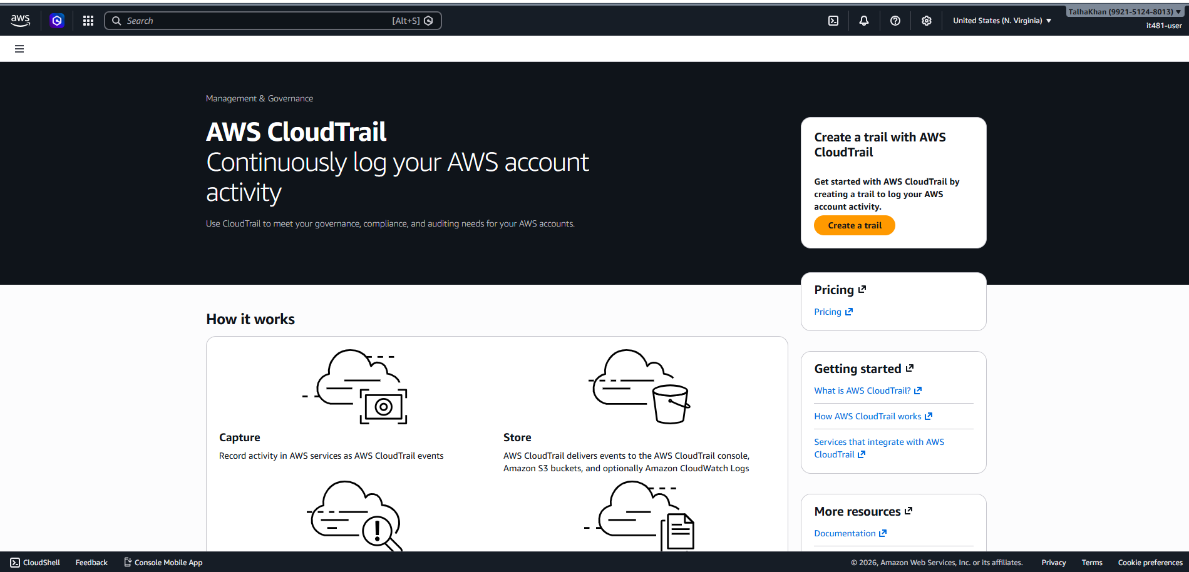
Step 2: Then, I clicked on “Create Trail”. 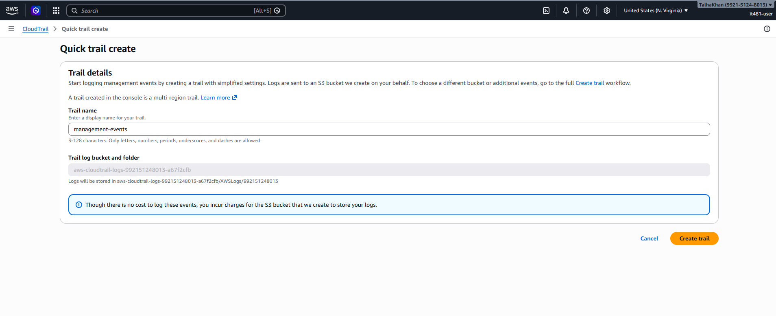 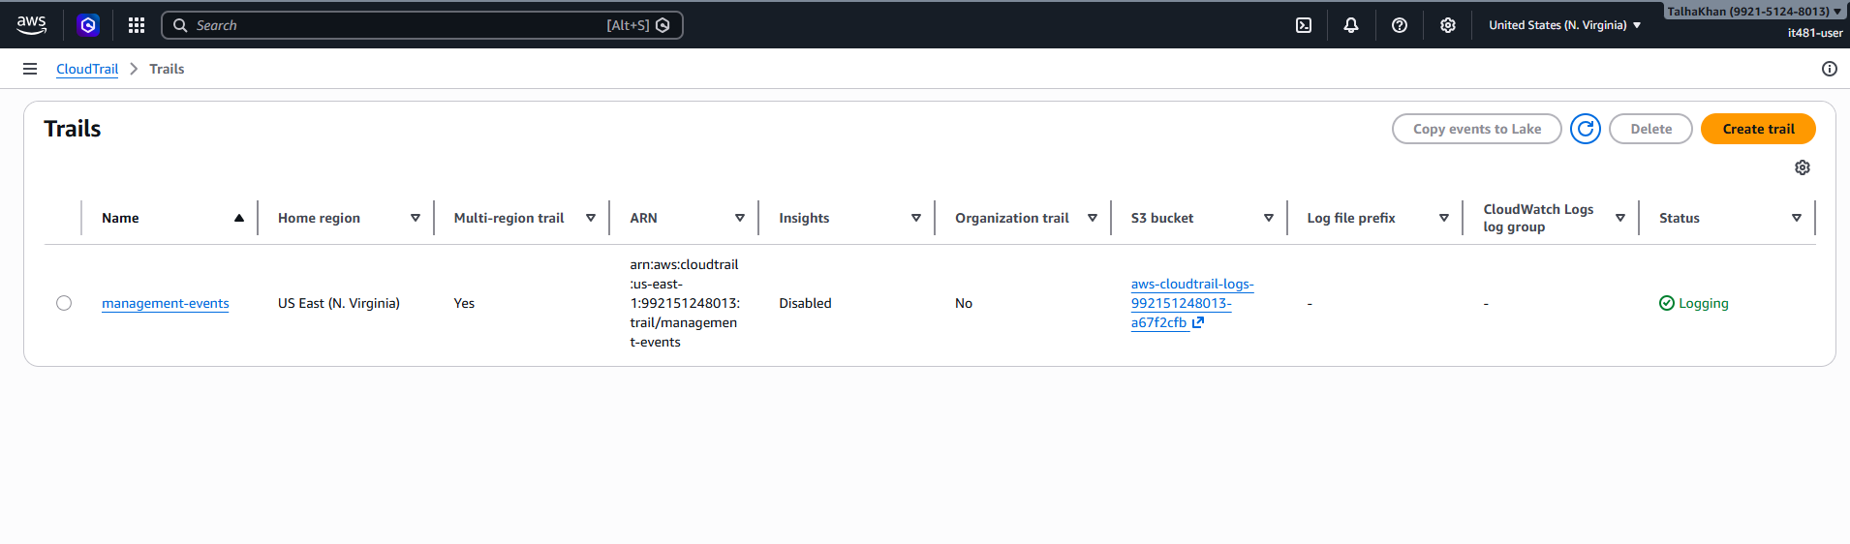
Step 3: To see the logs, I opened EC2 and S3 and viewed the instances and buckets. 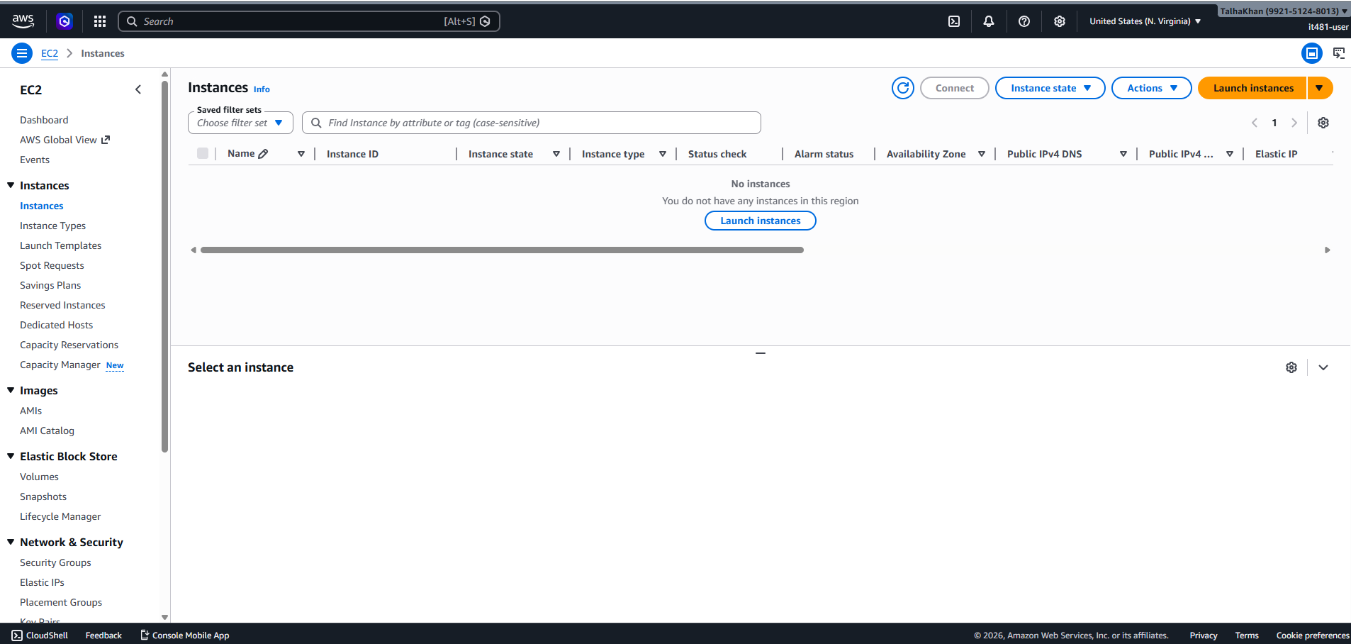 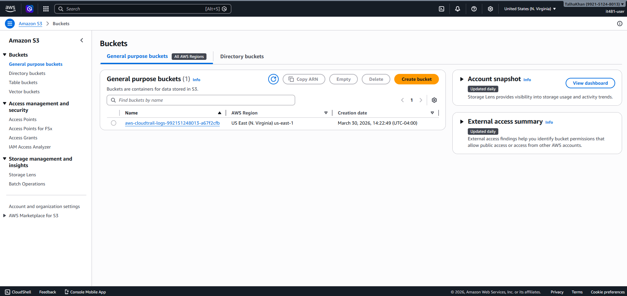
Step 4: Back in the CloudTrail, I clicked on “Event History” and observed the details. 